# 8. QUALITY MANAGEMENT PLAN

Quality management is an element that was introduced since the early stages of project management’s definition, sharing the same status as cost and time (Atkinson, 1999). It is an important aspect in project management where the performance of the product – the Integrated Supply Chain Management System in this scenario – is matching the required quality as mentioned in the project’s scope. For ensuring the quality of the product in development, actions and policies would be undertaken in form of three major processes:

* **Plan Quality Management**;
* **Performing Quality Assurance**; and
* **Performing Quality Control**

And in those three processes, some tools and techniques would be applicable in managing the project’s output quality, where it includes quality metrics, checklists, Pareto Charts, quality control charts, fishbone diagrams, maturity models and many others (Marchewka, 2014).

**Issues Involved**

|  |  |  |  |  |
| --- | --- | --- | --- | --- |
| **Quality Management** | | | | |
| **Issue No.** | **Issues** | **Project Management Process** | **Tools & Technique** |
| 9 | IT assets acquisition and spending were through PROC Manager with suppliers without going through a proper tendering process. | Execution | **Process Analysis**:  Conduct testing and checking the status to ensure the quality is top-notch. |
| 15 | Technical skills were especially lacking in the network and security areas. | Planning | **Group Decision-Making Techniques**:  Hiring a professional technical team to ensure all technical problems to assist with. |
| 18 | The hardware and software delivery were still being negotiated with some potential vendors while there were only four (4) months to complete the project. | Planning | **Design of Experiment**:  Testing is expected in the process, thus planning out the hardware and software that would be of use. |

## 8.1 Plan Quality Management

Planning would be the focus of this process. The content of planning includes **identifying which quality standards** are relevant to the project, and **methods required** to meet those standards. This is done to anticipate situations and prepare appropriate actions to bring out the needed outcome.

To devise a plan to an overall quality management, it is required to have a project management plan, stakeholder register, environmental factors and other available assets to deliver not only a **quality management plan**, but also **quality metrics**, **checklists** and relevant **updates to the project’s documentation** such as process improvement plan (Kima, et al., 2012).

While producing the deliverables, several tools and techniques could be adapted, in which **cost-benefit analysis** would be among the main methods to determine the capital required to create a system with high enough performance. Since the system in question has already developed by other regions, **benchmarking** techniques are applicable to compare for most suitable practices such as the database design (Cooper, et al., 2010). **Design of experiments** technique is also applicable to produce list of factors for the product in development (Gyung-Jin, 2007).

To solve **ISSUE NO. 18** where despite of the lack of time, negotiations with hardware and software delivery for the project is still undergoing, the **design of experiments** technique would assist in resolving the issue. In design of experiments, the 3 components of the project include *Factors*, *Levels* and *Response* as per illustrated in ***FIGURE 8.1.1***:

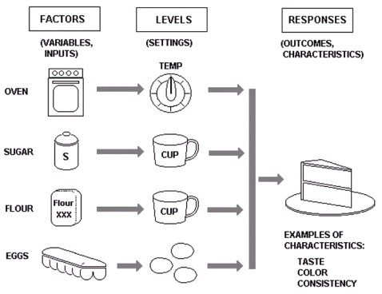

***FIGURE 8.1.1: Components of Design of Experiments (Example: Baking a Cake)***

For typical experiment designs, *Factors* would be inputs for the process; *Levels* being the weight and value set to each factor; and *Responses* being its output. While for the case in **ISSUE NO. 18**, the components in the design of experiments would be as follows:

* *Factor(s)*: Hardware & Software
* *Level(s)*: Performance (Hardware & Software); Price (Hardware & Software)
* *Response(s)*: Quality of Product (Integrated Supply Chain Management Software)

Based on the layout of the design of experiments, it could be found that the hardware and software used to develop the Integrated Supply Chain Management Software would be the main factor affecting the output, while their respective performance and price would be weighed.

To conduct a proper comparison for this experiment of *‘comparing hardware and software performance relative to pricing in ISCMP’*, a template should be made to collect each target’s data, as displayed in ***FIGURE 8.1.2***.

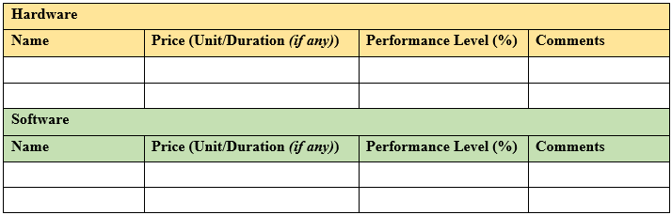

***FIGURE 8.1.2: Template of Hardware & Software Comparison for ISCMP***

While the names of each hardware and software are necessary, the **price** of these development assets would be considered by the price per duration, if any is mentioned. For example, the price of a Cloud subscription to Visual Studio Enterprise on monthly basis would take *$250/Month*. The **performance level** would determine how useful would it be in form of percentages. In this case, the performance of Visual Studio Enterprise would be considered 80% since most software developers would be using the system for coding the core mechanics. **Comments** serves more as a post script to mention any additional information regarding the target’s pricing or performance level. Using Visual Studio Enterprise as example, the comments may include ‘*inclusion of Azure Cloud service to share codes and track workloads’*.

## 8.2 Perform Quality Assurance

As the project is progressing, quality assurance is required to be performed to ensure all processes of the project can meet the relevant quality standards, in the meantime able to **achieve continuous quality improvement besides satisfying the minimum requirements** (Wandersman, et al., 2012).

While this process requires the input of most outputs from the planning process of quality management such as the quality management plan, process improvement plan and quality metrics, the process should be able to deliver a complete list of **change requests**, **updates on project management plan and its documentation**, including required **improvements on the available assets** (Taylor, 2018).

The deliverables of this process could be created with **quality management and control tools** like from the planning phase, such as leaning and benchmarking to maximizing output efficiency and minimizing waste, while ensure a compete-able quality with potential competitors (Larson & Gray, 2013). **Quality audits** are necessary too to measure how well is the monitoring of the project development matches the standard as per the project requested, identifying any lessons learned that could further improve the project’s output (Taylor, 2018). In the same time, **process analysis** would be conducted to examine the development processes so that in case of sidetracking, the processes could be tailored to align with the project requirements (Vergidis, et al., 2008).

To solve **ISSUE NO. 9** where the spending of IT assets passed through Procurement Management (PROC) without any tendering processes carried out. For solving this issue, the **process analysis** technique could be applied to create the tendering process. From this technique, the tendering process could be classified into several steps, in following order:

1. **Determine Tendering Types**
   * Selecting preferred format of tendering process such as:
     1. *Open Tendering*: Tender by public advertisements
     2. *Select Tendering*: Tenders selected via shortlisting from open tender(s)
     3. *Multi-stage Tendering*: Compare tenders from multiple stages featuring specific requirements
2. **Prepare Request for Tendering**
   * Prepare invitations to suppliers for competitive offer to win contract with ISCMP:
   * Must include description of the procured products; conditions to tender; relevant evaluation criteria, required submission content and format.
3. **Inviting Tenders**
   * Identify potential tenders who would likely respond to invitation
   * Contact project team regularly to find any future tender opportunities
4. **Response from Suppliers**
   * Receive all required documents from the suppliers
   * Hosting pre-tender briefing sessions to clarify any uncertainties
5. **Evaluation & Selection**
   * Check for compliance of each tender based on the evaluation criteria
   * Select tender(s) meeting the mandatory and technical requirements
6. **Notification & Debriefing**
   * Advice session for winning tenderer & debriefing
7. **Establish & Manage Contracts**
   * Form formal agreements between project team and the tenderer

According to the process analysis, there would be 7 steps where the PROC should follow to devise a proper tendering process to ensure all potential suppliers would be able to follow through the details the project team required tenderers to understand, while managing the standards of the supplier so the quality of Integrated Supply Management Chain Software would not suffer.

## 8.3 Control Quality

Quality control is a set of procedures that **verifies the quality of the project’s output**, determining that it is reaching the desired standards of the project scopes. This process is a vital aspect to measure the total quality of the project output, while identify any issues that needs to be resolved to meet the requirements set by the project stakeholders (Larson & Gray, 2013).

In this process, all data obtained from the planning and quality assurance processes would be inspected and further analyzed, and delivered not only **quality control measurements**, but also the **validated changes** and **updates on the project output**, along with **feedback on work performance** and **approved change requests**. In some occasions, **updates on the organizational process assets** would be conducted as well (Marchewka, 2014).

For precise data collection on quality control, **statistical sampling** plays an important role to understand the needs and details of features for the product in development (Martinez, et al., 2017). The **7 basic quality tools** that applies the use of storing collected data such as cause-and-effect diagram, flowcharts, to Pareto charts could help in organizing the data for clear input in data analysis (Soković, et al., 2009) to produce precise quality control measurements. However, in most cases a more direct approach, **inspection** on the workplace, would be taken to be able to provide performance feedback immediately. In the meantime, several **reviews on the change requests** would be conducted to determine those that require approval from high-ups such as project sponsors to be proceed. The change requests would most likely be reviewed via **Group Decision-Making** techniques where the technical aspect could be inspected by the professionals, when required.

To solve **ISSUE NO. 15** where the issue revolves around the severe lack in technical skills regarding network and security areas of the proposed software. In this context, **Group Decision-Making** techniques would be used to determine the requirements of deploying manpower on the network and security fields. While having **expert judgement** from the network and security professionals would help, the format for decision-making is equally vital too. For this case, a method called **Brainstorming**, where people would gather in groups and generate ideas freely. This helps in producing the requirements for the network and security area of the ISCMP. However, since this method focuses more on idea generation and not evaluation, the professional expert would come in play and **provide guidance and evaluation** regarding the proposed ideas.